CSCD327 – Lab4

1)

SELECT ORDERS.order_num, CUSTOMERS.firstname, CUSTOMERS.lastname, ORDERS.orderdate

FROM ORDERS NATURAL JOIN CUSTOMERS

WHERE shipdate is null

ORDER BY orderdate asc;

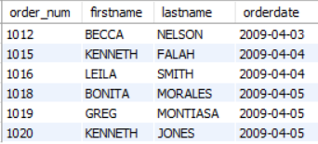

2)

SELECT CUSTOMERS.customer_num, CUSTOMERS.firstname, CUSTOMERS.lastname, ORDERITEMS.order_num

FROM CUSTOMERS NATURAL JOIN ORDERS

NATURAL JOIN ORDERITEMS

NATURAL JOIN BOOKS

WHERE BOOKS.Category = 'COMPUTER' and CUSTOMERS.State = 'FL';

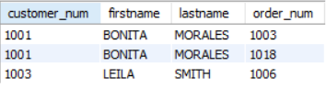

3)

SELECT DISTINCT BOOKS.title

FROM CUSTOMERS JOIN ORDERS

ON CUSTOMERS.Customer_num = ORDERS.Customer_num JOIN ORDERITEMS

ON ORDERS.Order_num = ORDERITEMS.Order_num JOIN BOOKS

ON BOOKS.ISBN = ORDERITEMS.ISBN

WHERE CUSTOMERS.FirstName = 'JAKE' and CUSTOMERS.LastName = 'LUCAS';

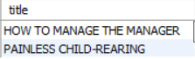

4)

SELECT BOOKS.title, ORDERS.orderdate, (ORDERITEMS.PaidEach - BOOKS.Cost) AS profit

FROM CUSTOMERS JOIN ORDERS

ON CUSTOMERS.Customer_num = ORDERS.Customer_num JOIN ORDERITEMS

ON ORDERS.Order_num = ORDERITEMS.Order_num JOIN BOOKS

ON BOOKS.ISBN = ORDERITEMS.ISBN

WHERE CUSTOMERS.FirstName = 'JAKE' and CUSTOMERS.LastName = 'LUCAS'

ORDER BY ORDERS.orderdate asc, profit desc;

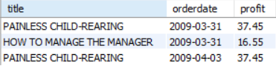

5)

SELECT BOOKS.ISBN, BOOKS.Title

FROM AUTHOR JOIN BOOKAUTHOR

ON AUTHOR.AuthorID = BOOKAUTHOR.AuthorID JOIN BOOKS

ON BOOKAUTHOR.ISBN = BOOKS.ISBN

WHERE AUTHOR.Lname = 'ADAMS';



6)

SELECT AUTHOR.fname, AUTHOR.lname, BOOKS.title

FROM CUSTOMERS JOIN ORDERS

USING(customer_num) JOIN ORDERITEMS

USING(order_num) JOIN BOOKS

USING(isbn) JOIN BOOKAUTHOR

USING(isbn) JOIN AUTHOR

USING(authorid)

WHERE CUSTOMERS.FirstName = 'BECCA' and CUSTOMERS.LastName = 'NELSON';

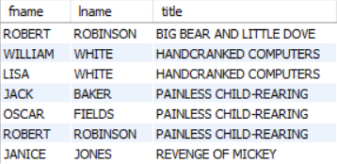

7)

SELECT BOOKS.Title, ORDERS.Order_num, CUSTOMERS.State

FROM BOOKS LEFT JOIN ORDERITEMS

ON BOOKS.ISBN = ORDERITEMS.ISBN LEFT JOIN ORDERS

ON ORDERITEMS.Order_num = ORDERS.Order_num LEFT JOIN CUSTOMERS

ON ORDERS.Customer_num = CUSTOMERS.Customer_num;

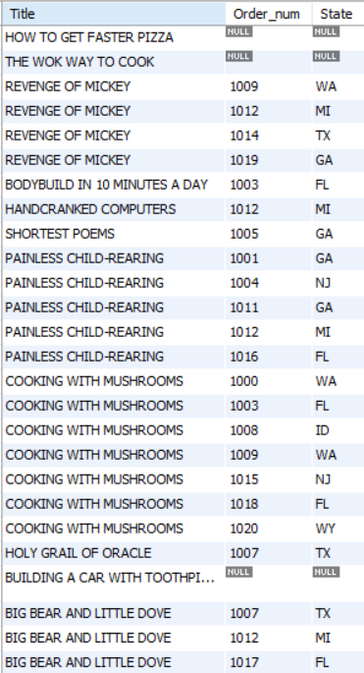

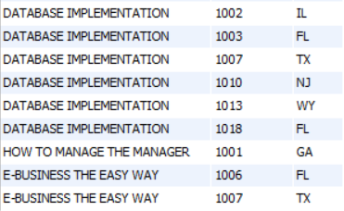

8)

SELECT COUNT(*)

FROM BOOKS

WHERE BOOKS.Retail >= 30;



9)

SELECT MAX(pubdate)

FROM BOOKS;



10)

SELECT SUM((BOOKS.Retail - BOOKS.Cost)*ORDERITEMS.Quantity) AS 'Total Profit'

FROM CUSTOMERS JOIN ORDERS

USING(customer_num) JOIN ORDERITEMS

USING(order_num) JOIN BOOKS

USING(isbn)

WHERE CUSTOMERS.Customer_num = 1017;

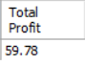

11)

SELECT MIN(retail)

FROM BOOKS;



12)

SELECT customer_num, COUNT(*)

FROM ORDERS

GROUP BY customer_num;

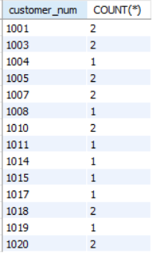

13)

SELECT PUBLISHER.Name, BOOKS.Category, AVG(Retail)

FROM BOOKS JOIN PUBLISHER

USING(PubID)

WHERE BOOKS.Category IN(PUBLISHER.Name, BOOKS.Category)

AND (BOOKS.Retail > 50)

GROUP BY PUBLISHER.Name, BOOKS.Category;

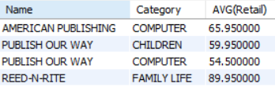

14)

SELECT CUSTOMERS.FirstName, CUSTOMERS.LastName, ORDERS.Order_num, SUM(retail * quantity) AS Total

FROM CUSTOMERS JOIN ORDERS

USING(customer_num) JOIN ORDERITEMS

USING(order_num) JOIN BOOKS

USING(isbn)

WHERE CUSTOMERS.State = 'FL' OR CUSTOMERS.State = 'GA'

GROUP BY order_num desc

HAVING SUM(retail * quantity) > 80;

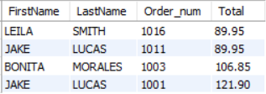

15)

SELECT MAX(retail)

FROM BOOKS JOIN BOOKAUTHOR

USING(isbn) JOIN AUTHOR

USING(AuthorID)

WHERE AUTHOR.Fname = 'LISA'

AND AUTHOR.Lname = 'WHITE';

